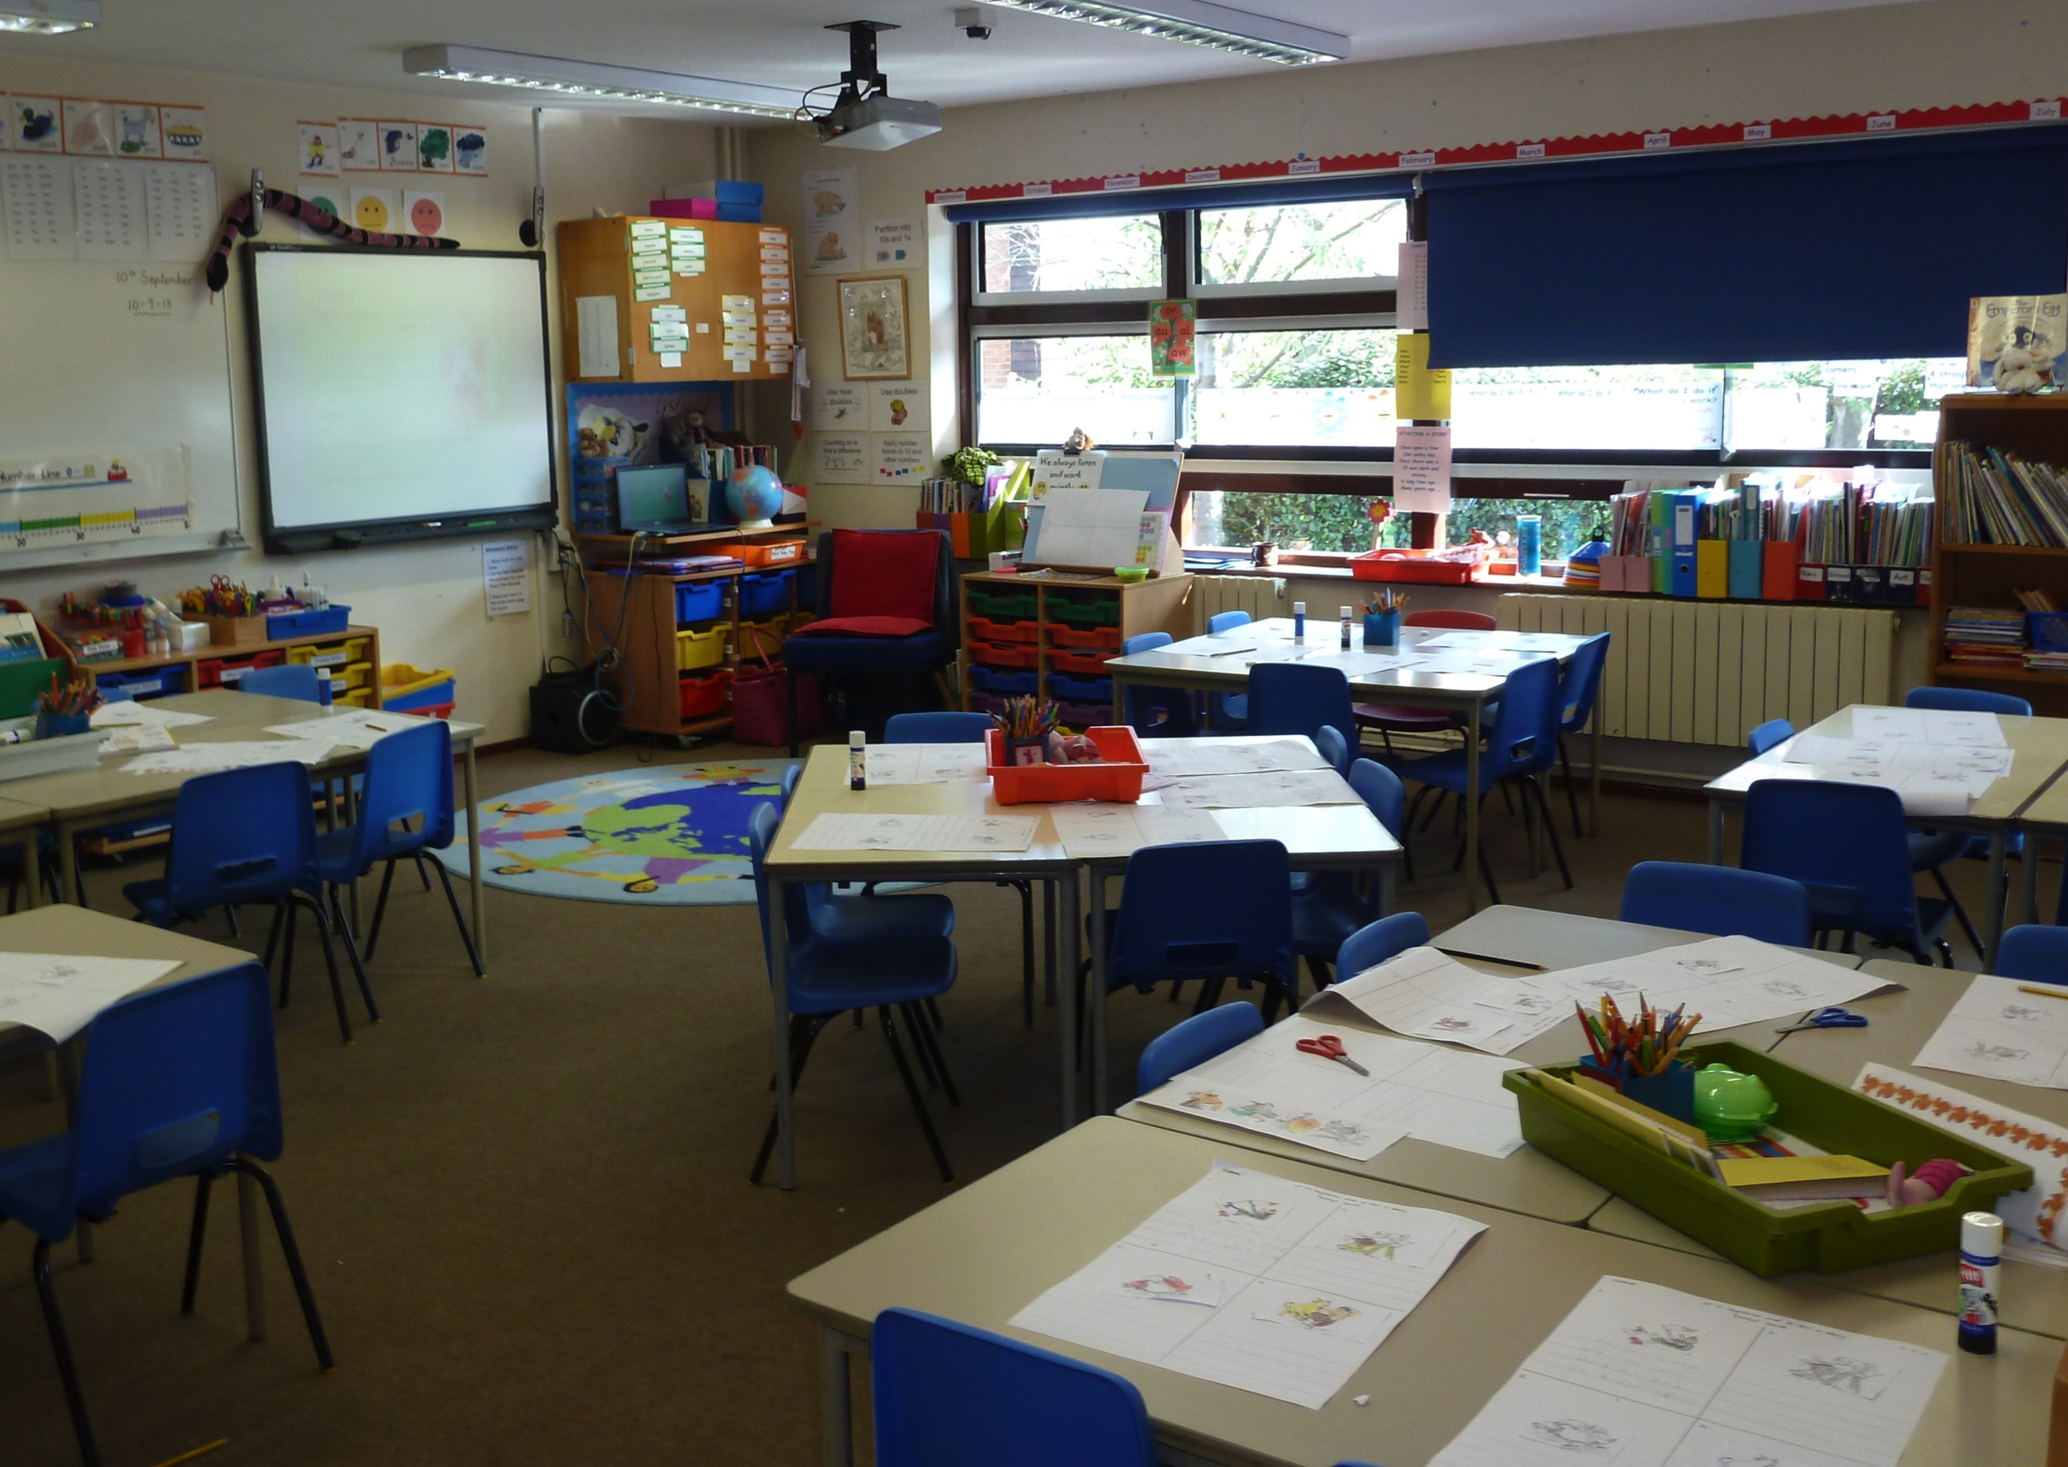

**Code: rim of box denotes**

**Teacher-initiated; Teacher-facilitated; Child-led**

**Purple text indicates links to RE subject content.**

***Some content links to more than one key question (key questions in bold text)***

What makes our school a special place?

**School celebrations:**

‘belonging’ at school through assemblies, Harvest & Christmas ***BELONGING / CELEBRATIONS***



**STORIES**

‘Kipper’ series: Mick Inkpen

‘Elmer’ books – David McKee

‘It’s good to be 5’ – Jamie Lee-Curtis

**What does it feel like in this special place?**

Write a speech bubble

*EVIDENCE OPPORTUNITY*

***SPECIAL PLACES***

photograph & write captions about our own special places *EVIDENCE OPPORTUNITY*

***SPECIAL PLACES***

**Meeting / sharing stories about special people in these communities *BELONGING / STORIES***

**My home as a special place of belonging *BELONGING / SPECIAL PLACES***

**God creates people / the Creation story (Bible / Torah / Qur’an) *WONDERFUL WORLD***

**‘…I am special, my friend is special’**

Make ‘two-faced’ (double-sided) faces on paper plates of themselves & friend, by observation

*EVIDENCE OPPORTUNITY* ***WONDERFUL WORLD***

Who’s in our class / school family?

**Circle time: Mirror in a box:** celebrating uniqueness

***BELONGING***

**Discussion:** what makes us the same? What makes us different?

Photograph special people in our school

Bring in baby photos: how have we changed?

**This version uses learning from several different key questions, so demonstrates more how different aspects of the RE curriculum for EYFS might link together in a ‘journey’. There are plenty of opportunities for other EYFS elements linked with this wider theme. There is also more than one way to complete the journey!**

What other buildings are special to people? ***SPECIAL PLACES***

**Visit church** – what makes ‘church’ a special place?

***SPECIAL PLACES***

**Birth-days and welcoming new babies** e.g. christening, naming, whispering adhan etc. ***BELONGING / CELEBRATIONS***

**Belonging:** how do religious people show they belong together? Look at photos.

*EVIDENCE OPPORTUNITY* ***BELONGING / CELEBRATIONS***

**Me and my family**

Take photos / paint pictures of the new class in their uniforms

**My school: a learning journey for EYFS**